UML Model Exchange through XMI
Altova UModel® 2011 lets you import and export models as industry standard XMI files for maximum UML compatibility.
XMI (XML Metadata Interchange) is the portion of the UML specification that describes the method for storing UML models in a standardized XML-based interchange format. UModel® 2011 supports the latest XMI version – XMI 2.1 – both to import XMI files describing UML models created in other applications and to export UModel projects.
Support for industry-standard XMI import and export creates opportunities to extend the benefits of UML in large development teams. You can add copies of UModel® 2011 to work alongside – or even to replace – higher-priced, or cumbersome, legacy UML tools. UModel® 2011 users can import models saved in XMI 2.1 format by other tools. Team members can also employ XMI export to share UModel® 2011 projects with specialized UML add-ons such as model execution and debugging tools that are not required by the entire project team.
XMI 2.1 supports the latest UML 2.3 standard, and also permits backward compatibility with UML 2.0, UML 2.1, and UML 2.2. UModel® 2011 can import XMI 2.1 files that describe models in any UML version.
The XMI Import and XMI Export options are easily accessible from the File menu.
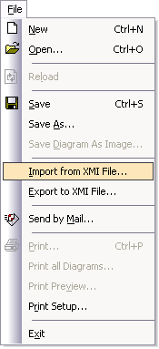
When you import an XMI file to create a new UModel project, status is reported in the message window.
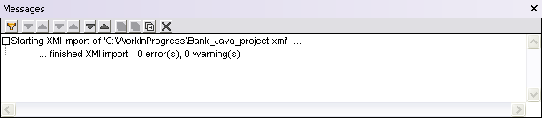
Successful import of the XMI file creates a new UML model project, with each element defined and fully editable exactly as if the project had been originally created in UModel® 2011. You can select elements of the imported project and open diagrams to display content or relationships within the model.

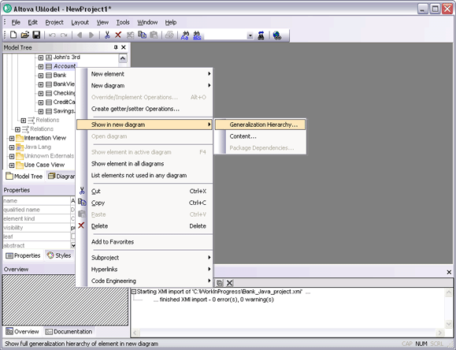
Click image to enlarge screenshot

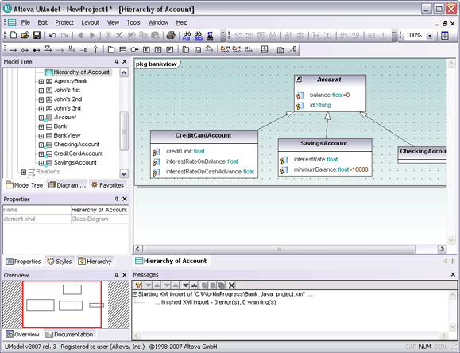

ArgoUML
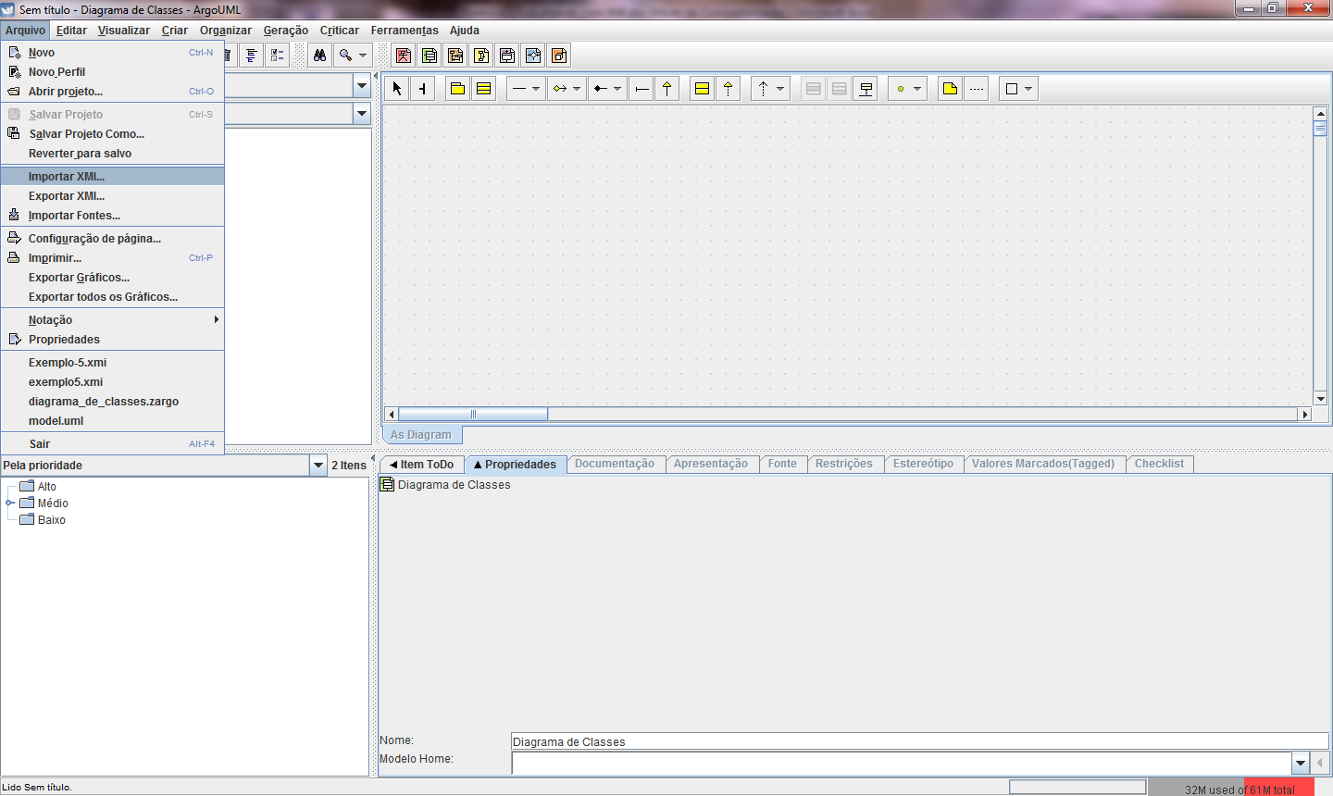
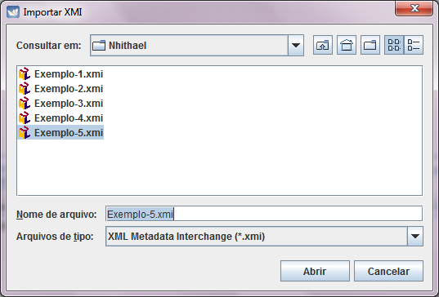

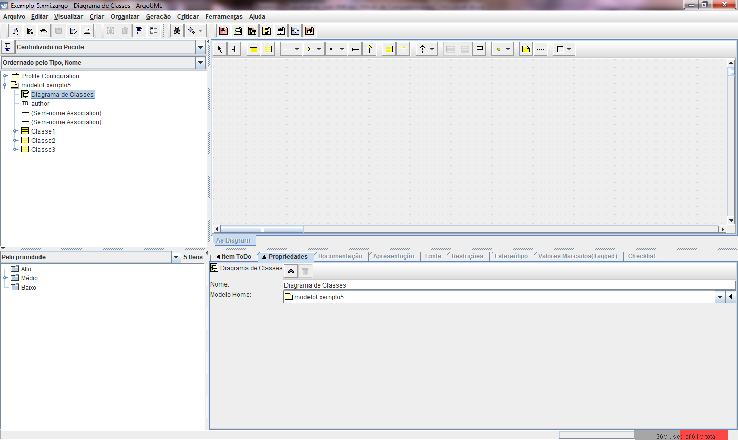
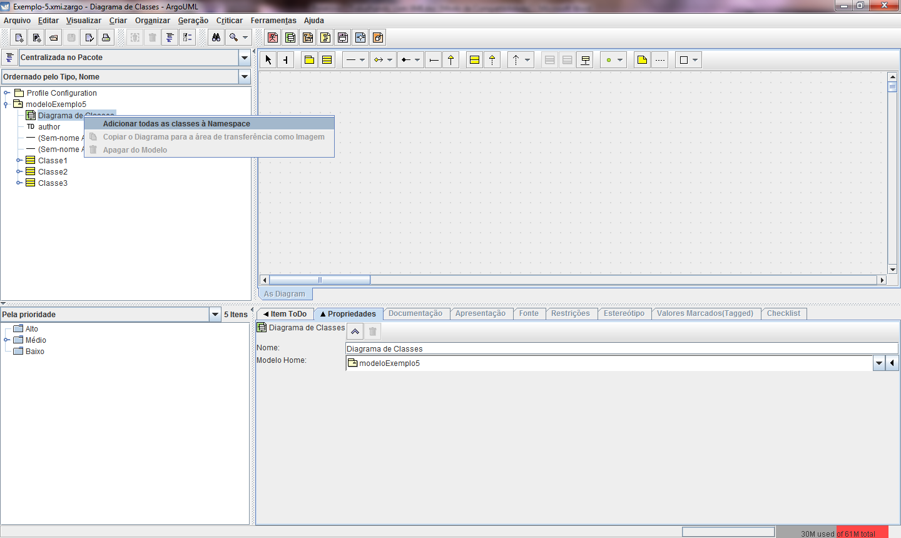

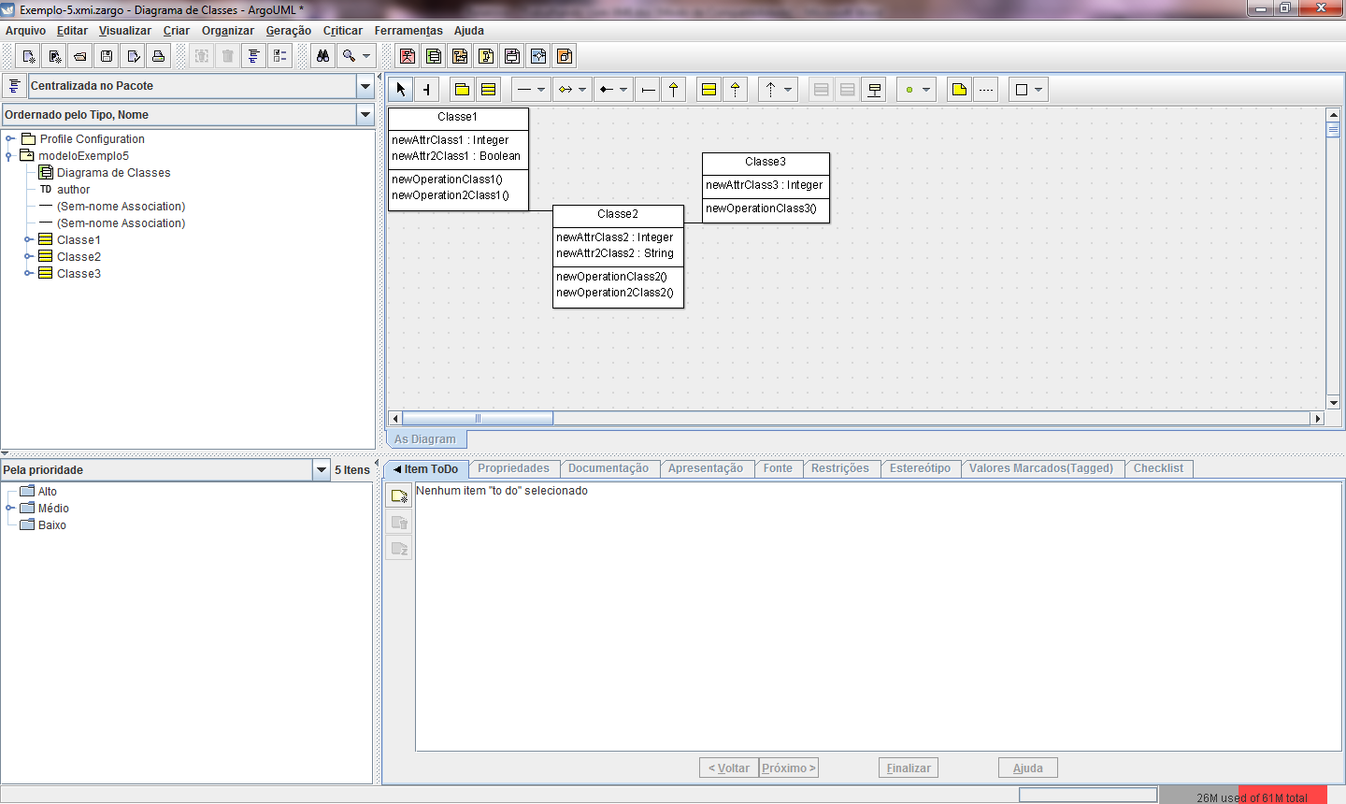

EA – Enterprise Architect

